Coding Question (30 pt):

Initialize a new git repository in your working directory, create a new branch and make reasonable commits with meaningful messages to track your changes in that branch. Merge everything back to the master branch when you're done. Include a screenshot of result of git log command with your submission. The screenshot should show that all the commits from the new branch are in the master/main branch (2 pt)

Have a new **PRIVATE**remote repository on github and push all your commits from your main/master branch in your local repo to the remote repo. Add NikuYou (my marker) as your collaborator. Include the link to your github repository in your submission. (2 pt)

Recreate the finished example:

Note: Right-click on the hyperlinks and open in a new tab.

* Follow this file structure (1 pt)

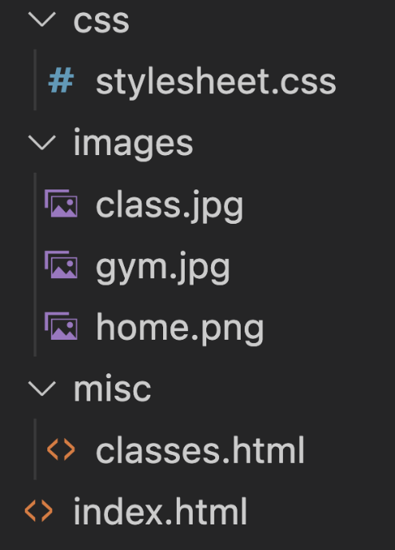

* You can download the images from <https://github.com/nchangizi/midterm>
* Use only external styling. Re-use one stylesheet for both HTML pages. Your CSS shouldn't include duplicate styling (Group selectors or re-use a class) (2 pt)
* You should use proper semantic tags in all HTML pages (2 pt)
* Correct and validated syntax (2 pt)
* Use colors in this palette for backgrounds and general text color <https://coolors.co/412234-8c6cb2-cfbbd2-ead7d7>  (2 pt)
* Set the font for all the headings except h1 on classes.html page to Bree Serif, and all the other texts on both pages to Montserrat regular 400 (include the stylesheets for both fonts from <https://fonts.google.com/> ) (2 pt)
* You could get placeholder text from here: <https://loremipsum.io/>
* To create the navigation, use unordered list (4 pt)
  + "About Us" navigation item should scroll the page to the About Us section. It should work from **both** index.html and the classes.html page.
  + "Classes" navigation item should take the user to the Classes page.
  + The Home icon should take the user to the index.html page.
  + Notice the dashed line under the navigation area
* Navigation items should be shown in darkslateblue before getting clicked, and red:100, green:8, and blue:80 after being visited. (2 pt)
* Make the top navigation menu stick to the top of the viewport when the user scrolls (3 pt).
  + Hint: apply proper value for width property of that section (make it span the whole width)
* Use a **combinator** selector to change the bullet shape of Morning and Evening items under Group Classes section to square (2 p)
* Only the first paragraph in index.html page should be rendered next to the gym image. (2 pt)
* Center the image on the classes.html (1 pt)
* Apply margin and padding to create some spaces similar to the provided screenshots (1 pt)

**Submission:**

* A zipped file of your working directory
* GitHub link
* Screenshot of git log